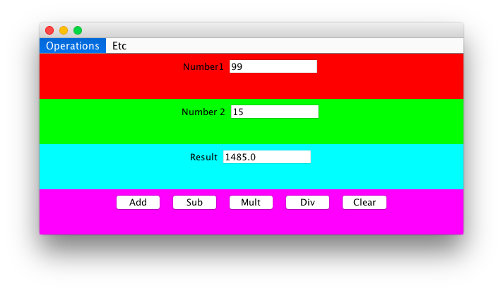

**import** java.awt.Color;

**import** java.awt.GridLayout;

**import** java.awt.event.ActionEvent;

**import** java.awt.event.ActionListener;

**import** javax.swing.JButton;

**import** javax.swing.JFrame;

**import** javax.swing.JLabel;

**import** javax.swing.JMenu;

**import** javax.swing.JMenuBar;

**import** javax.swing.JMenuItem;

**import** javax.swing.JPanel;

**import** javax.swing.JTextField;

**public** **class** JFrameExt **extends** JFrame **implements** ActionListener {

**private** **static** **final** **long** ***serialVersionUID*** = 1L;

**private** JPanel jpMain = **new** JPanel();

**private** JPanel jp1 = **new** JPanel();

**private** JPanel jp2 = **new** JPanel();

**private** JPanel jp3 = **new** JPanel();

**private** JPanel jp4 = **new** JPanel();

**private** JLabel jlbNum1 = **new** JLabel("Number1");

**private** JLabel jlbNum2 = **new** JLabel("Number 2");

**private** JLabel jlbRes = **new** JLabel("Result");

**private** JTextField jtfNum1 = **new** JTextField(10);

**private** JTextField jtfNum2 = **new** JTextField(10);

**private** JTextField jtfRes = **new** JTextField(10);

**private** JButton jbtAdd = **new** JButton("Add");

**private** JButton jbtSub = **new** JButton("Sub");

**private** JButton jbtMult = **new** JButton("Mult");

**private** JButton jbtDiv = **new** JButton("Div");

**private** JButton jbtC = **new** JButton("Clear");

**private** JMenuBar jmbMain = **new** JMenuBar();

**private** JMenu jmuOp = **new** JMenu ( "Operations");

**private** JMenu jmuEtc = **new** JMenu ( "Etc");

**private** JMenuItem jmiAdd = **new** JMenuItem ( "add");

**private** JMenuItem jmiSub = **new** JMenuItem ( "sub");

**private** JMenuItem jmiMult = **new** JMenuItem ( "mult");

**private** JMenuItem jmiDiv = **new** JMenuItem ( "div");

**private** JMenuItem jmiClear = **new** JMenuItem ( "clear");

**public** JFrameExt() {

jpMain.setBackground(Color.***yellow***);

jp1.setBackground(Color.***red***);

jp2.setBackground(Color.***green***);

jp3.setBackground(Color.***cyan***);

jp4.setBackground(Color.***magenta***);

**this**.setContentPane(jpMain);

// GridLayout gl = new GridLayout(4,1);

jpMain.setLayout(**new** GridLayout(4,1));

jpMain.add(jp1);

jpMain.add(jp2);

jpMain.add(jp3);

jpMain.add(jp4);

**this**.setContentPane(jpMain);

//add object to panels

jp1.add(jlbNum1);

jp1.add(jtfNum1);

jp2.add(jlbNum2);

jp2.add(jtfNum2);

jp3.add(jlbRes);

jp3.add(jtfRes);

jtfRes.setEditable(**false**);

jp4.add(jbtAdd);

jp4.add(jbtSub);

jp4.add(jbtMult);

jp4.add(jbtDiv);

jp4.add(jbtC);

//handle menus

jmbMain.add(jmuOp);

jmbMain.add(jmuEtc);

jmuOp.add(jmiAdd);

jmuOp.add(jmiSub);

jmuOp.add(jmiMult);

jmuOp.add(jmiDiv);

//set the menu bars

jmuEtc.add(jmiClear);

**this**.setJMenuBar(jmbMain);

//register

jbtAdd.addActionListener(**this**);

jbtSub.addActionListener(**this**);

jbtMult.addActionListener(**this**);

jbtDiv.addActionListener(**this**);

jbtC.addActionListener(**this**);

jmiAdd.addActionListener(**this**);

jmiSub.addActionListener(**this**);

jmiMult.addActionListener(**this**);

jmiDiv.addActionListener(**this**);

jmiClear.addActionListener(**this**);

}

**public** **void** actionPerformed(ActionEvent ev) {

**double** num1, num2, res;

String resS;

num1 = Double.*parseDouble*(jtfNum1.getText().trim());

num2 = Double.*parseDouble*(jtfNum2.getText().trim());

// +

**if** (ev.getSource() == jbtAdd) {

res = num1 + num2;

resS = Double.*toString*(res);

jtfRes.setText(resS);

}

//-

**else** **if** (ev.getSource() == jbtSub) {

res = num1 - num2;

resS = Double.*toString*(res);

jtfRes.setText(resS);

}

// *

**else** **if** (ev.getSource() == jbtMult) {

res = num1 * num2;

resS = Double.*toString*(res);

jtfRes.setText(resS);

}

// /

**else** **if** (ev.getSource() == jbtDiv) {

res = num1 / num2;

resS = Double.*toString*(res);

jtfRes.setText(resS);

}

**else** **if** (ev.getSource() == jbtC) {

jtfNum1.setText(**null**);

jtfNum2.setText(**null**);

jtfRes.setText(**null**);

}

}

}

**public** **class** Main {

**public** **static** **void** main(String[] args) {

JFrameExt f = **new** JFrameExt();

f.setSize(600, 300);

f.setVisible(**true**);

}

}